**Mandatory hands-on**

**Spring REST using Spring Boot 3**

**Exercise 1: Create a Spring Web Project using Maven**

**Code:**

SME Walkthrough: Spring Web Project

1. `src/main/java` — Application Code

* This is where Java source code resides.

* Path: `src/main/java/com/cognizant/spring_learn`

Includes all:

* Controllers (e.g., REST APIs)

* Services (business logic)

* Models (data objects/entities)

* Configuration classes

* Main class (`SpringLearnApplication.java`)

2. `src/main/resources` — Application Configuration

* This folder contains configuration files like:

* `application.properties` or `application.yml`

for:

* Server port

* DB config

* Logging

3. `src/test/java` — Test Code

* This is where all JUnit test classes go.

* Follows the same package structure as `main/java`

* Uses `spring-boot-starter-test` for full testing support

4. `SpringLearnApplication.java` — Main Class

@SpringBootApplication

public class SpringLearnApplication {

private static final Logger LOGGER = LoggerFactory.getLogger(SpringLearnApplication.class);

public static void main(String[] args) {

SpringApplication.run(SpringLearnApplication.class, args);

LOGGER.info("Inside main");

}

}

* `SpringApplication.run(...)` bootstraps and runs the Spring app.

* `LOGGER.info(...)` logs a message to verify the entry point works.

5. `@SpringBootApplication`

It’s a meta-annotation and others:

|  |  |
| --- | --- |
| Annotation | Purpose |
| `@Configuration` | Marks class as a source of bean definitions |
| `@EnableAutoConfiguration` | Enables Spring Boot’s auto-configuration feature |
| `@ComponentScan` | Scans the current package and subpackages for beans |

6. pom.xml

<project xmlns=*"http://maven.apache.org/POM/4.0.0"*

xmlns:xsi=*"http://www.w3.org/2001/XMLSchema-instance"*

xsi:schemaLocation=*"http://maven.apache.org/POM/4.0.0*

*http://maven.apache.org/xsd/maven-4.0.0.xsd"*>

<modelVersion>4.0.0</modelVersion>

<groupId>com.cognizant</groupId>

<artifactId>spring-learn</artifactId>

<version>0.0.1-SNAPSHOT</version>

<name>spring-learn</name>

<description>Spring Web Project Example</description>

<packaging>jar</packaging>

<parent>

<groupId>org.springframework.boot</groupId>

<artifactId>spring-boot-starter-parent</artifactId>

<version>2.7.18</version>

<relativePath/>

</parent>

<properties>

<java.version>17</java.version>

</properties>

<dependencies>

<dependency>

<groupId>org.springframework.boot</groupId>

<artifactId>spring-boot-starter</artifactId>

</dependency>

<dependency>

<groupId>org.springframework.boot</groupId>

<artifactId>spring-boot-starter-web</artifactId>

</dependency>

<dependency>

<groupId>org.springframework.boot</groupId>

<artifactId>spring-boot-devtools</artifactId>

<scope>runtime</scope>

</dependency>

<dependency>

<groupId>org.springframework.boot</groupId>

<artifactId>spring-boot-starter-test</artifactId>

<scope>test</scope>

</dependency>

</dependencies>

<build>

<plugins>

<plugin>

<groupId>org.apache.maven.plugins</groupId>

<artifactId>maven-compiler-plugin</artifactId>

<version>3.8.1</version>

<configuration>

<source>${java.version}</source>

<target>${java.version}</target>

</configuration>

</plugin>

</plugins>

</build>

</project>

**Output:**

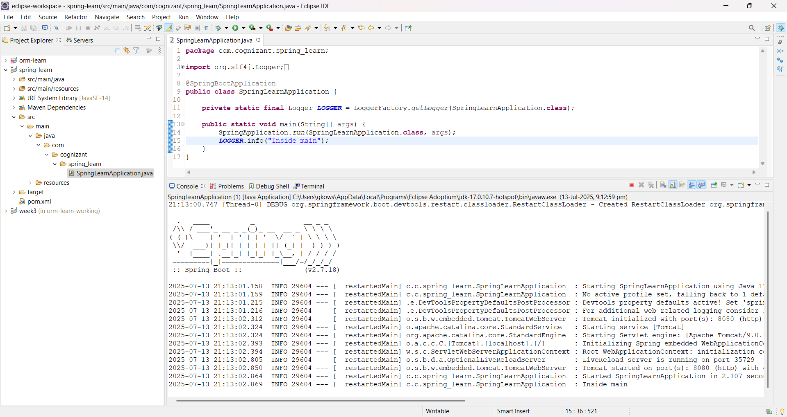

**Exercise 4: Spring Core – Load Country from Spring Configuration XML**

**Code:**

**SpringLearnApplication.java**

package com.cognizant.springlearn;

import org.slf4j.Logger;

import org.slf4j.LoggerFactory;

import org.springframework.context.ApplicationContext;

import org.springframework.context.support.ClassPathXmlApplicationContext;

public class SpringLearnApplication {

private static final Logger *LOGGER* = LoggerFactory.*getLogger*(SpringLearnApplication.class);

public static void main(String[] args) {

*displayCountry*();

}

public static void displayCountry() {

try {

ApplicationContext context = new ClassPathXmlApplicationContext("country.xml");

Country country = (Country) context.getBean("country", Country.class);

System.*out*.println("Output: " + country);

} catch (Exception e) {

e.printStackTrace();

}

}

}

**Country.java**

package com.cognizant.springlearn;

import org.slf4j.Logger;

import org.slf4j.LoggerFactory;

public class Country {

private static final Logger *LOGGER* = LoggerFactory.*getLogger*(Country.class);

private String code;

private String name;

public Country() {

*LOGGER*.debug("Inside Country Constructor.");

}

public String getCode() {

*LOGGER*.debug("Inside getCode()");

return code;

}

public void setCode(String code) {

*LOGGER*.debug("Inside setCode()");

this.code = code;

}

public String getName() {

*LOGGER*.debug("Inside getName()");

return name;

}

public void setName(String name) {

*LOGGER*.debug("Inside setName()");

this.name = name;

}

@Override

public String toString() {

return "Country [code=" + code + ", name=" + name + "]";

}

}

**pom.xml**

<project xmlns=*"http://maven.apache.org/POM/4.0.0"*

xmlns:xsi=*"http://www.w3.org/2001/XMLSchema-instance"*

xsi:schemaLocation=*"http://maven.apache.org/POM/4.0.0*

*http://maven.apache.org/xsd/maven-4.0.0.xsd"*>

<modelVersion>4.0.0</modelVersion>

<groupId>com.cognizant</groupId>

<artifactId>spring-learn-country-xml</artifactId>

<version>0.0.1-SNAPSHOT</version>

<packaging>jar</packaging>

<properties>

<java.version>17</java.version>

</properties>

<dependencies>

<dependency>

<groupId>org.springframework</groupId>

<artifactId>spring-context</artifactId>

<version>5.3.33</version>

</dependency>

<dependency>

<groupId>org.slf4j</groupId>

<artifactId>slf4j-api</artifactId>

<version>1.7.36</version>

</dependency>

<dependency>

<groupId>org.slf4j</groupId>

<artifactId>slf4j-simple</artifactId>

<version>1.7.36</version>

</dependency>

</dependencies>

<build>

<plugins>

<plugin>

<groupId>org.apache.maven.plugins</groupId>

<artifactId>maven-compiler-plugin</artifactId>

<version>3.8.1</version>

<configuration>

<source>${java.version}</source>

<target>${java.version}</target>

</configuration>

</plugin>

</plugins>

</build>

</project>

**Output:**

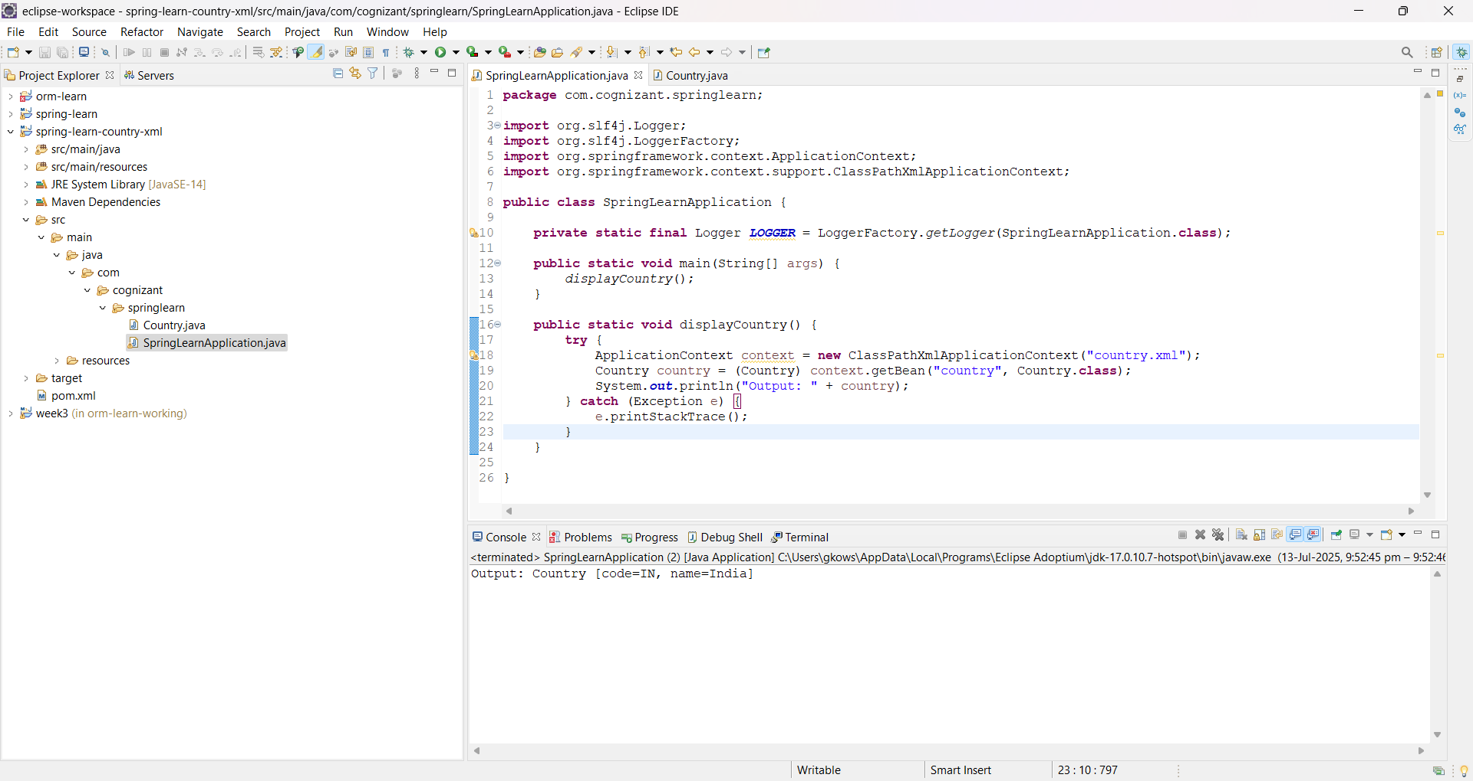

**Exercise: Hello World RESTful Web Service**

**Code:**

**HelloController.java**

package com.cognizant.springlearn.controller;

import org.slf4j.Logger;

import org.slf4j.LoggerFactory;

import org.springframework.web.bind.annotation.GetMapping;

import org.springframework.web.bind.annotation.RestController;

@RestController

public class HelloController {

private static final Logger LOGGER = LoggerFactory.getLogger(HelloController.class);

@GetMapping("/hello")

public String sayHello() {

LOGGER.info("START sayHello()");

String message = "Hello World!!";

LOGGER.info("END sayHello()");

return message;

}

}

**SpringLearnApplication.java**

package com.cognizant.springlearn;

import org.slf4j.Logger;

import org.slf4j.LoggerFactory;

import org.springframework.boot.SpringApplication;

import org.springframework.boot.autoconfigure.SpringBootApplication;

@SpringBootApplication

public class SpringLearnApplication {

private static final Logger LOGGER = LoggerFactory.getLogger(SpringLearnApplication.class);

public static void main(String[] args) {

LOGGER.info("START");

SpringApplication.run(SpringLearnApplication.class, args);

LOGGER.info("END");

}

}

**Output:**

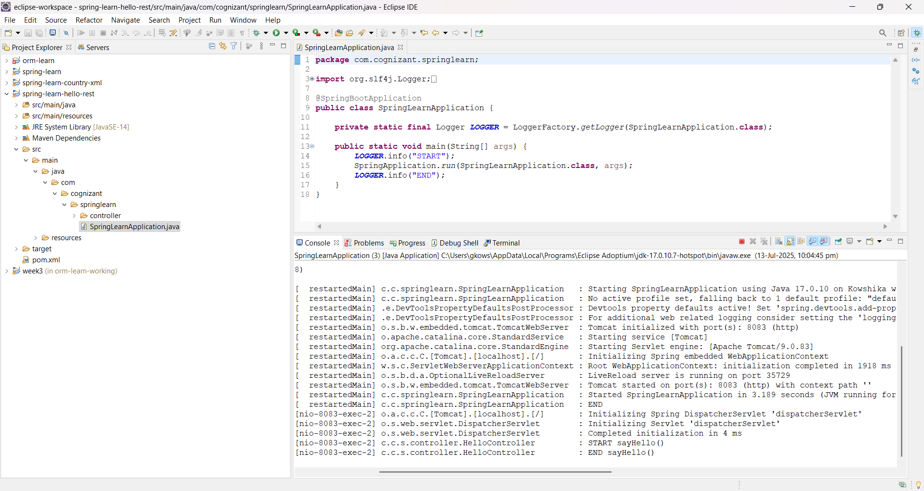

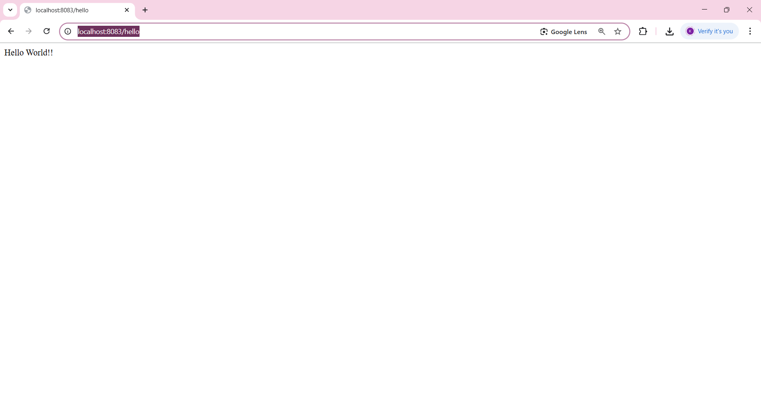

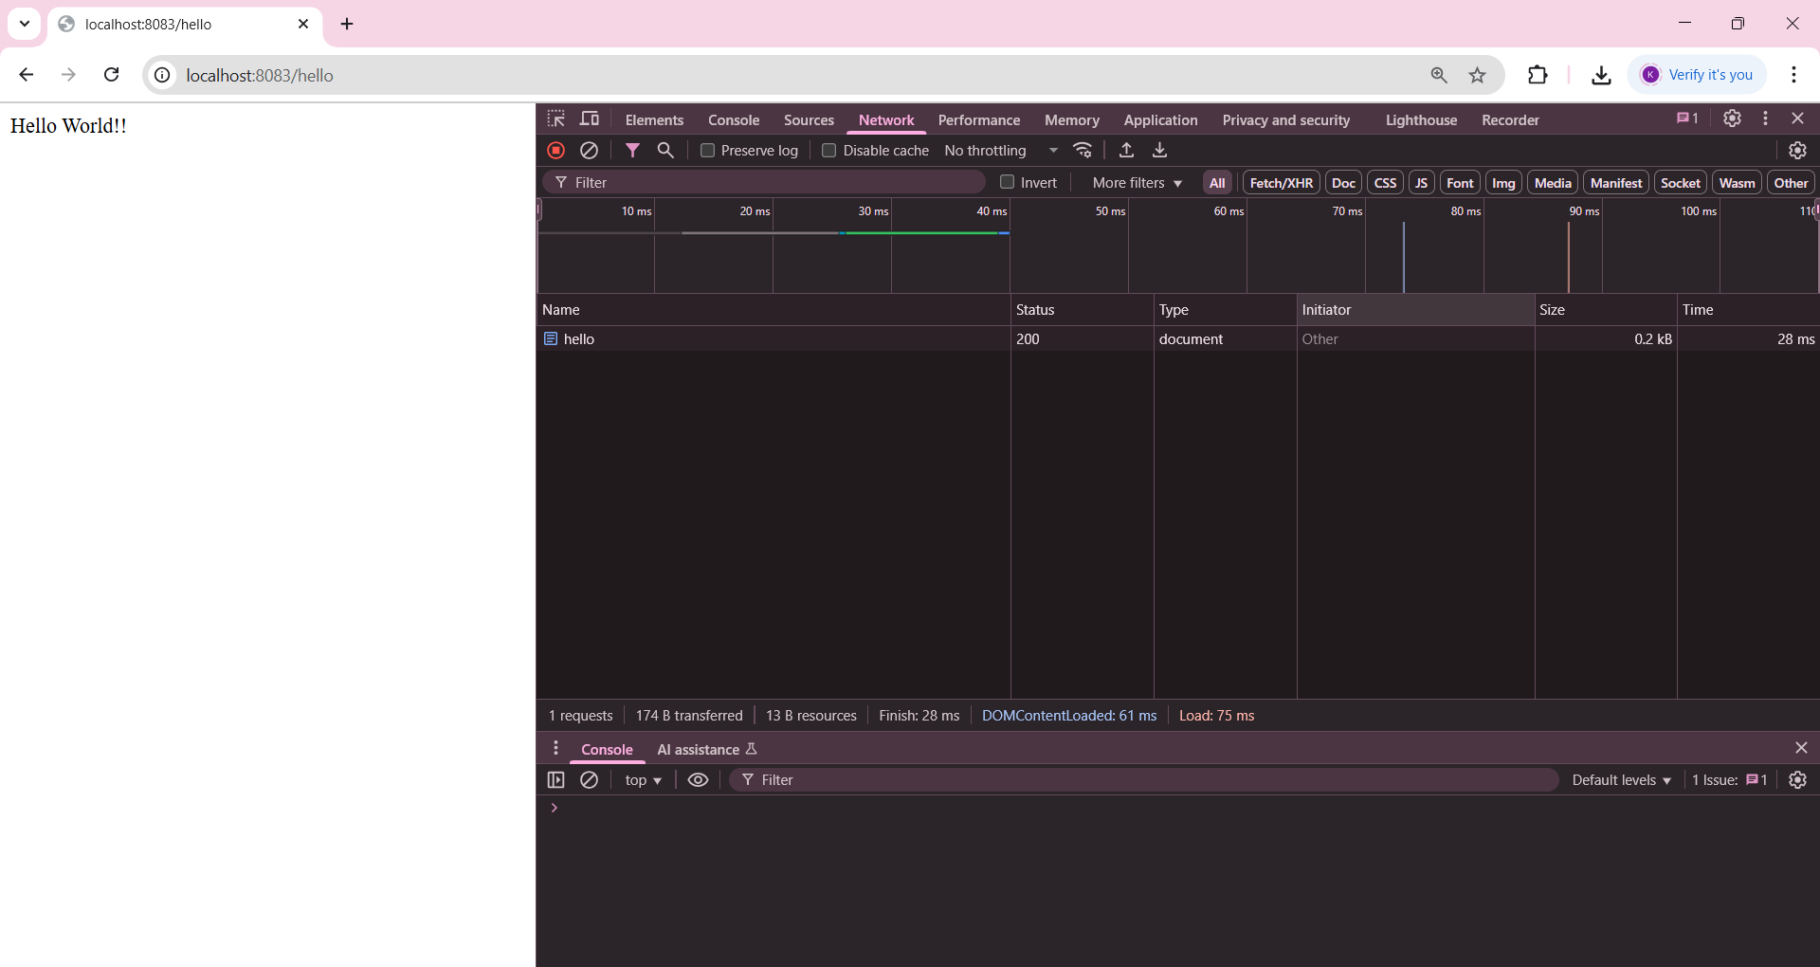

**Exercise: REST - Country Web Service**

**Code:**

**CountryController.java**

package com.cognizant.spring_learn.controller;

import com.cognizant.spring_learn.model.Country;

import org.springframework.beans.factory.xml.XmlBeanFactory;

import org.springframework.core.io.ClassPathResource;

import org.springframework.web.bind.annotation.RequestMapping;

import org.springframework.web.bind.annotation.RestController;

@RestController

public class CountryController {

@RequestMapping("/country")

public Country getCountryIndia() {

XmlBeanFactory factory = new XmlBeanFactory(new ClassPathResource("spring.xml"));

Country country = (Country) factory.getBean("country");

return country;

}

}

**Country.java**

package com.cognizant.spring_learn.model;

public class Country {

private String code;

private String name;

public String getCode() {

return code;

}

public void setCode(String code) {

this.code = code;

}

public String getName() {

return name;

}

public void setName(String name) {

this.name = name;

}

}

**SpringLearnApplication.java**

package com.cognizant.spring_learn;

import org.springframework.boot.SpringApplication;

import org.springframework.boot.autoconfigure.SpringBootApplication;

@SpringBootApplication

public class SpringLearnApplication {

public static void main(String[] args) {

SpringApplication.run(SpringLearnApplication.class, args);

}

}

**Output:**

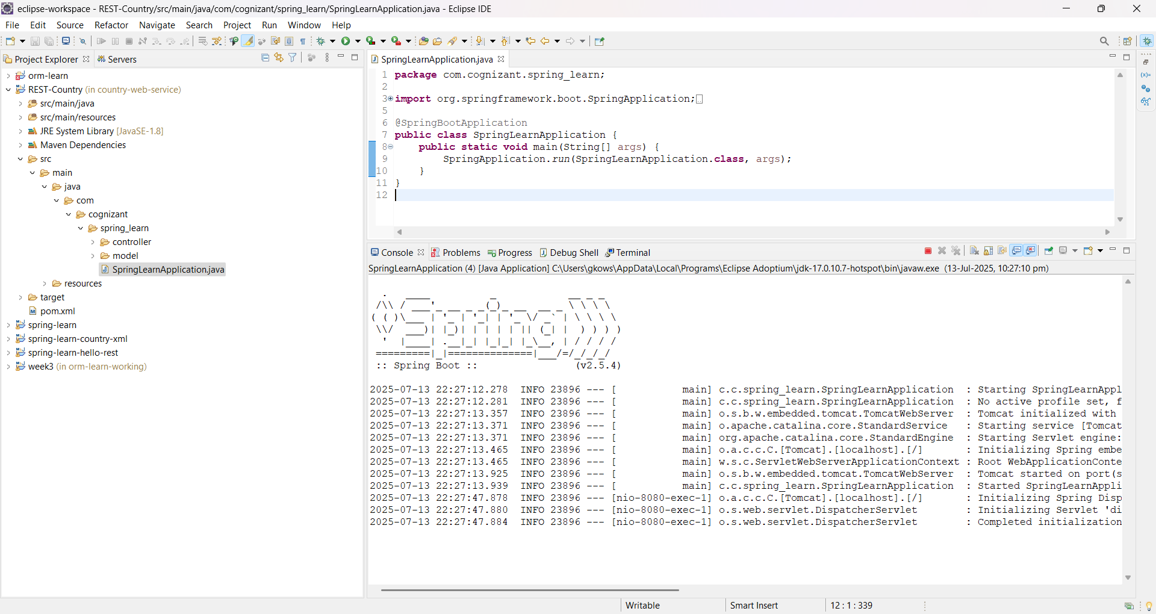

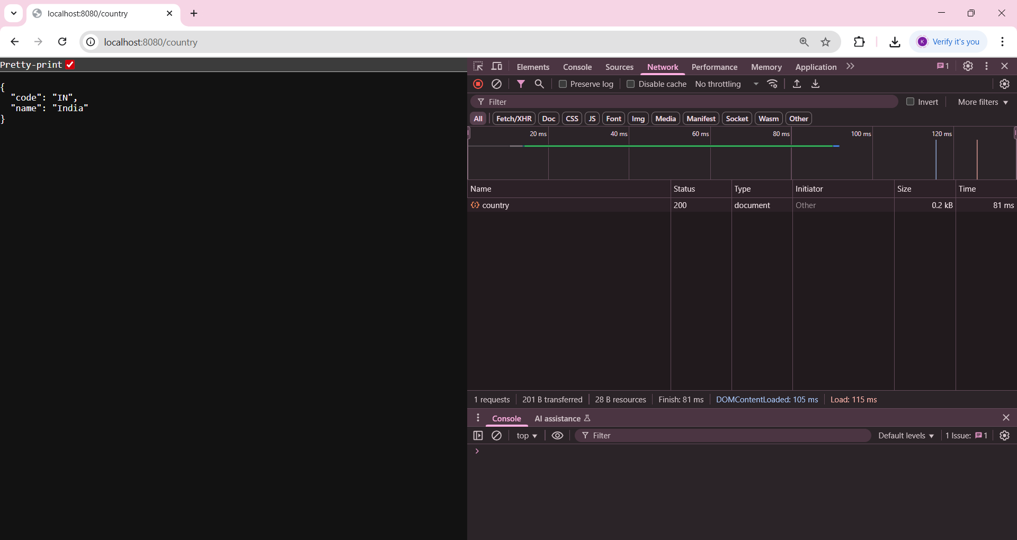

**Exercise: REST - Get country based on country code**

**Code:**

**CountryController.java**

package com.cognizant.spring_learn.controller;

import com.cognizant.spring_learn.model.Country;

import com.cognizant.spring_learn.service.CountryService;

import org.springframework.beans.factory.annotation.Autowired;

import org.springframework.web.bind.annotation.*;

@RestController

public class CountryController {

@Autowired

private CountryService countryService;

@RequestMapping("/country")

public Country getCountryIndia() {

org.springframework.beans.factory.xml.XmlBeanFactory factory =

new org.springframework.beans.factory.xml.XmlBeanFactory(

new org.springframework.core.io.ClassPathResource("spring.xml"));

Country country = (Country) factory.getBean("country");

return country;

}

@GetMapping("/countries/{code}")

public Country getCountry(@PathVariable String code) {

return countryService.getCountry(code);

}

}

**Country.java**

package com.cognizant.spring_learn.model;

public class Country {

private String code;

private String name;

public String getCode() {

return code;

}

public void setCode(String code) {

this.code = code;

}

public String getName() {

return name;

}

public void setName(String name) {

this.name = name;

}

}

**CountryService.java**

package com.cognizant.spring_learn.service;

import com.cognizant.spring_learn.model.Country;

import org.springframework.beans.factory.xml.XmlBeanFactory;

import org.springframework.core.io.ClassPathResource;

import org.springframework.stereotype.Service;

import java.util.List;

@Service

public class CountryService {

public Country getCountry(String code) {

XmlBeanFactory factory = new XmlBeanFactory(new ClassPathResource("country.xml"));

List<Country> countries = (List<Country>) factory.getBean("countryList");

return countries.stream()

.filter(c -> c.getCode().equalsIgnoreCase(code))

.findFirst()

.orElse(null);

}

}

**SpringLearnApplication.java**

package com.cognizant.spring_learn;

import org.springframework.boot.SpringApplication;

import org.springframework.boot.autoconfigure.SpringBootApplication;

@SpringBootApplication

public class SpringLearnApplication {

public static void main(String[] args) {

SpringApplication.run(SpringLearnApplication.class, args);

}

}

**Output:**

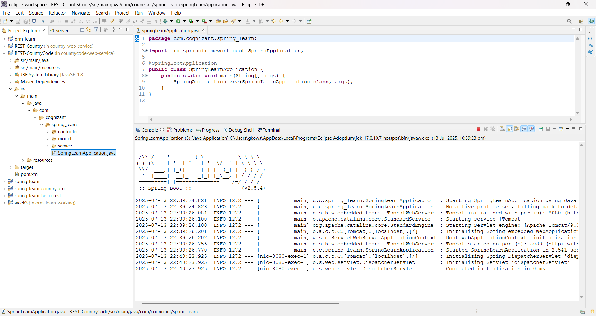

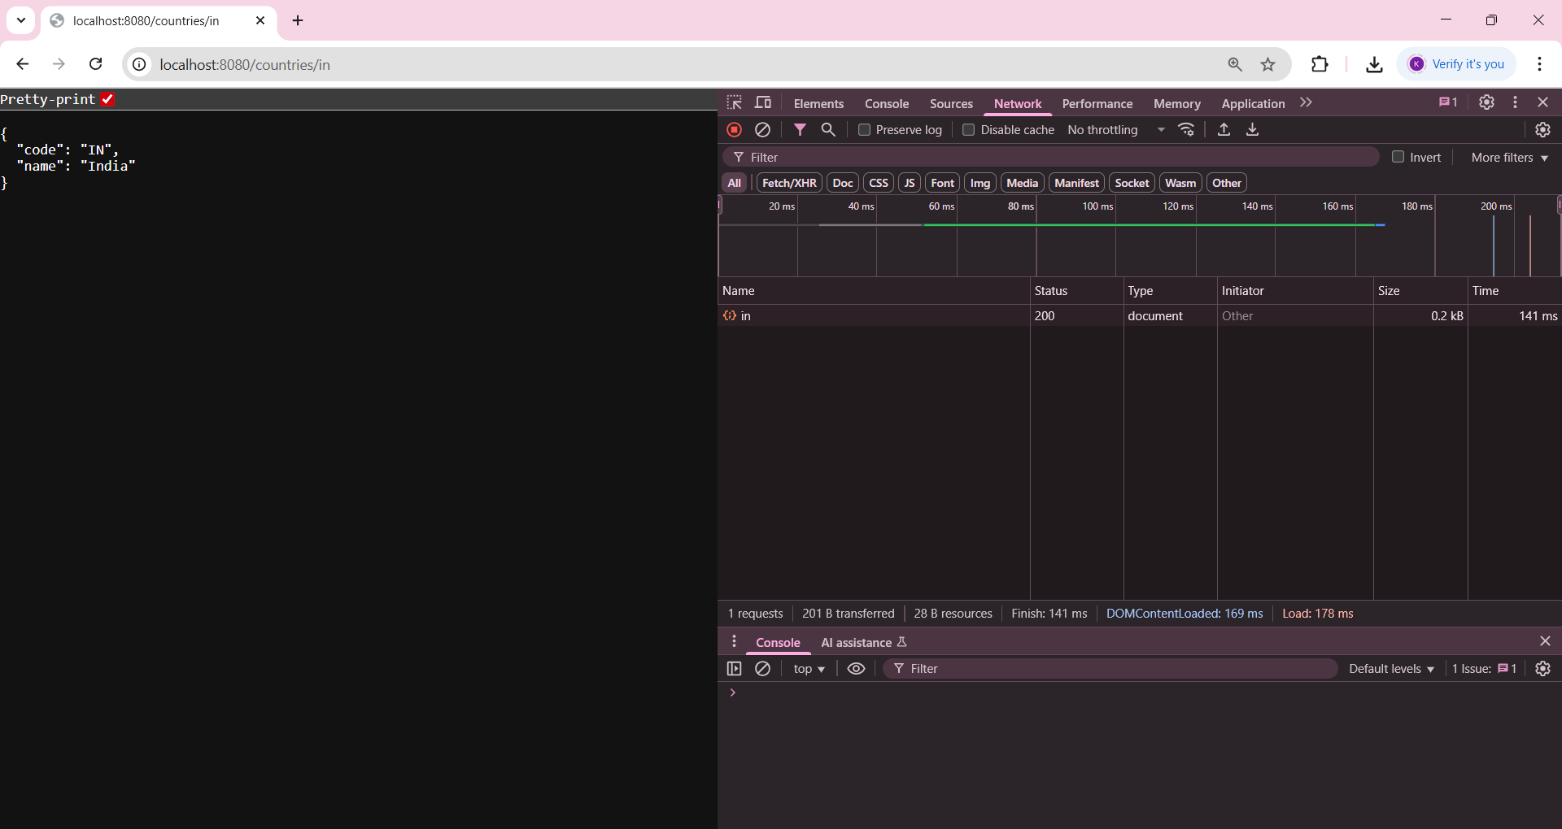

**Exercise:** **Create authentication service that returns JWT**

**Code:**

**AuthenticationController.java**

package com.cognizant.spring_learn.controller;

import io.jsonwebtoken.Jwts;

import io.jsonwebtoken.SignatureAlgorithm;

import org.springframework.http.ResponseEntity;

import org.springframework.web.bind.annotation.*;

import javax.servlet.http.HttpServletRequest;

import java.util.Base64;

import java.util.Date;

@RestController

public class AuthenticationController {

private static final String SECRET_KEY = "secretkey123";

@RequestMapping(value = "/authenticate", method = RequestMethod.GET)

public ResponseEntity<?> authenticate(HttpServletRequest request) {

String authHeader = request.getHeader("Authorization");

if (authHeader != null && authHeader.startsWith("Basic")) {

String base64Credentials = authHeader.substring("Basic".length()).trim();

byte[] credDecoded = Base64.getDecoder().decode(base64Credentials);

String credentials = new String(credDecoded);

final String[] values = credentials.split(":", 2);

String username = values[0];

String password = values[1];

// Hardcoded credentials check (user:pwd)

if ("user".equals(username) && "pwd".equals(password)) {

String token = Jwts.builder()

.setSubject(username)

.setIssuedAt(new Date(System.currentTimeMillis()))

.setExpiration(new Date(System.currentTimeMillis() + 1000 * 60 * 10)) // 10 min expiry

.signWith(SignatureAlgorithm.HS256, SECRET_KEY)

.compact();

return ResponseEntity.ok("{\"token\":\"" + token + "\"}");

}

}

return ResponseEntity.status(401).body("Unauthorized");

}

}

**SecurityConfig.java**

package com.cognizant.spring_learn.security;

import org.springframework.context.annotation.Configuration;

import org.springframework.security.config.annotation.web.builders.HttpSecurity;

import org.springframework.security.config.annotation.web.configuration.WebSecurityConfigurerAdapter;

@SuppressWarnings("deprecation")

@Configuration

public class SecurityConfig extends WebSecurityConfigurerAdapter {

@Override

protected void configure(HttpSecurity http) throws Exception {

http.csrf().disable()

.authorizeRequests().anyRequest().permitAll();

}

}

**SpringLearnApplication.java**

package com.cognizant.spring_learn;

import org.springframework.boot.SpringApplication;

import org.springframework.boot.autoconfigure.SpringBootApplication;

@SpringBootApplication

public class SpringLearnAuthApplication {

public static void main(String[] args) {

SpringApplication.run(SpringLearnAuthApplication.class, args);

}

}

**Output:**



